**Ideation Phase**

**Define the Problem Statements**

|  |  |
| --- | --- |
| Date | 20 May 2023 |
| Team ID | NM2023TMID02223 |
| Project Name | Industrial workers health and safety system based on the IOT |
| Maximum Marks | 2 Marks |

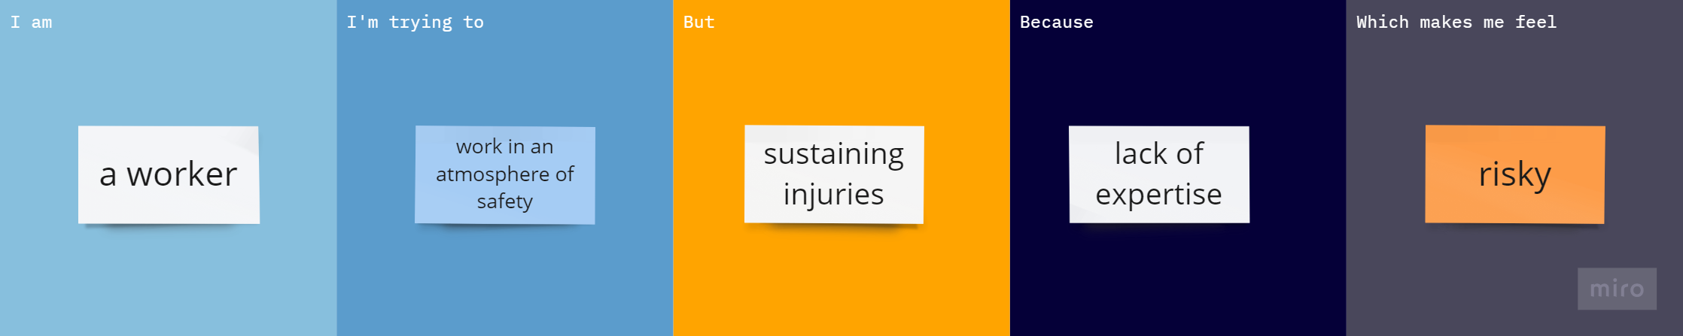

|  |  |  |  |  |  |
| --- | --- | --- | --- | --- | --- |
| **Problem Statement (PS)** | **I am (Customer)** | **I’m trying to** | **But** | **Because** | **Which makes me feel** |
| PS-1 | a worker | work in an atmosphere of safety | sustaining injuries | lack of expertise | risky |